ChBE 4412 Design Project Phase 1

Due midsemester

This case study was contributed by Dr. Tom Badgwell:
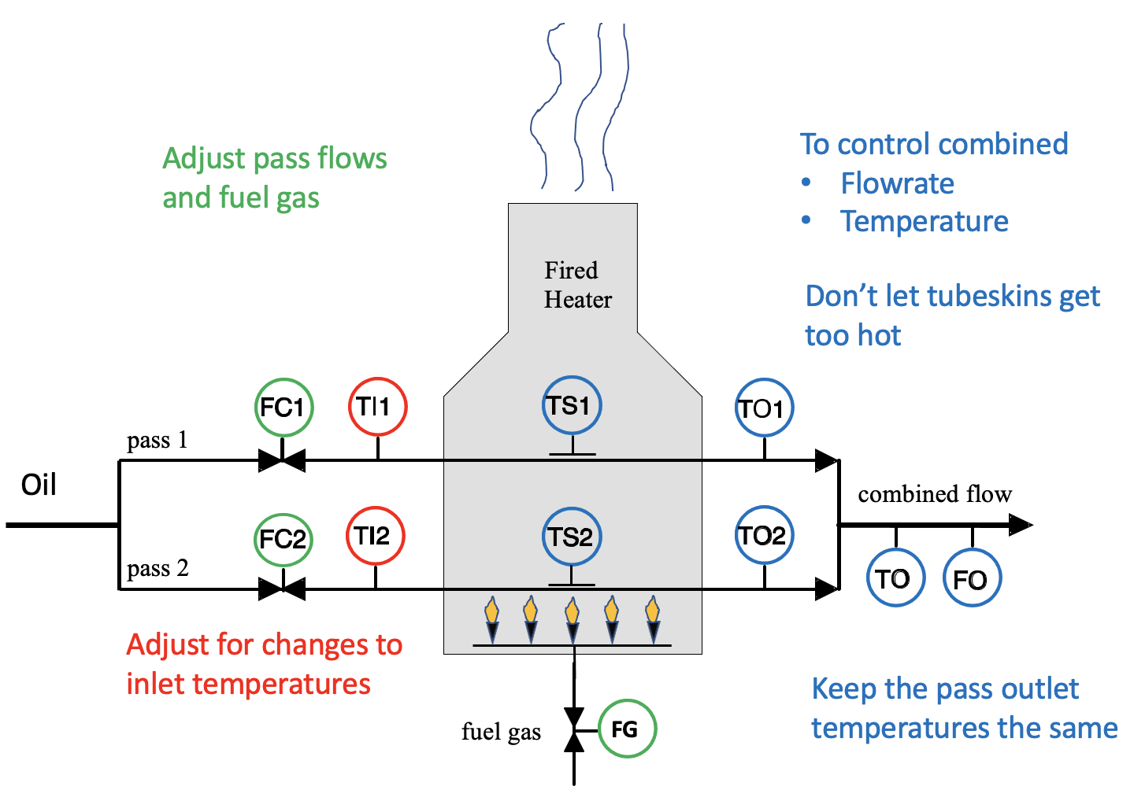

Quantity | Abbreviation | Units
Actuators
Flow Controller 1 | FC1 | barrels per hour (BPH)
Flow Controller 2 | FC2 | barrels per hour (BPH)
Fuel Gas Flow | FG | thousand standard cubic feet per hour (MSCFH)
Sensors
Inlet temperature 1 | TI1 | °F
Inlet temperature 2 | TI2 | °F
Tubeskin temperature 1 | TS1 | °F
Tubeskin temperature 2 | TS2 | °F
Outlet temperature 1 | TO1 | °F
Outlet temperature 2 | TO2 | °F
Temperature of combined outlet | TO | °F
Total flow rate in output | FO | barrels per hour (BPH)

Resources

- Videos
  - Overview
  - Refinery Process Control
  - Fired Heater Control Problem
  - Fired Heater Manual Operation
- Go through the activities in “Fired Heater MPC Simulation Tutorial”, including installation of the software.
- Read “Model Predictive Control in Practice” by Badgwell and Qin

Learning objectives
- Understand the differences between mechanistic modeling and empirical modeling, including advantages and disadvantages of each approach
- Be able to classify a response as linear or nonlinear using data (here it is data from a simulation)
- Understand why multi-input multi-output models are needed for control in practice

Assignment

- Construct a dynamic process model for the fired heater, using mass and energy balances. The model should include all of the controlled variables (CV), manipulated variables (MV), and disturbance variables (DV). For this step, use only variables, not numerical values. State all of your assumptions. Comment on which parameters in your model are unknown, how you might estimate them, and whether or not the model is linear or nonlinear. Consider how you can capture the key phenomena, without creating a model that is overly complicated, especially given the limited information that is available to you.

- The process is designed to operate at steady state with a total flowrate of 200 barrels per hour, with 100 BPH in pass 1 and 100 BPH in pass 2. The fuel gas flow rate is 95 MSCFH of natural gas, and the inlet temperature is 540°F. Perform this experiment using the software tool.

  - What are the steady-state values of the CVs?
  - How much heat is released from the burning of the fuel gas, assuming that the natural gas combustion is complete?
  - What is the increase in enthalpy of the oil?
  - What is the overall efficiency of the heating process?
  - How can you use this steady-state information to estimate parameters in your model from Question 1?

- Operating at steady state, the fuel gas is suddenly changed to 97 MSCFH. Perform this experiment using the software tool.
  - What are the new steady-state values of the CVs?
  - How fast do the CVs respond to this step change?
  - How can you use this new information to estimate additional parameters in your model from Question 1?

- What additional experiments should you perform to gain more information for constructing your process model? Perform additional experiments and use this information for building your model.

- Is the relationship between the inlet flow rate FC1 and the outlet temperature TO linear or nonlinear, in the simulation tool? Perform numerical experiments and provide evidence for your conclusion.

- How would you construct an empirical model for this process (instead of using mass and energy balances)? Construct an empirical model for the relationship between fuel gas and outlet temperature, using data from the simulation tool.

“Model Predictive Control in Practice, T. A. Badgwell and S. J. Qin, J. Baillieul, T. Samad (eds.), Encyclopedia of Systems and Control, Springer-Verlag London Ltd., part of Springer Nature 2019, https://doi.org/10.1007/978-1-4471-5102-9 8-2

